OPERATION AND CALIBRATION OF ANALYTICAL BALANCE
- 
darshan doshi
- Jul 3, 2022
- 4 min read
Updated: Jan 22, 2024
Many users have requested to highlight some SOP for Calibration of Analytical Balance. As a result, we got in touch with some of the experts with having experience in Pharmaceutical Manufacturing Industries. Based on their inputs we have tried to create a SOP for Calibration of Analytical Balances.

Standard Operating Procedure (SOP) for operation and calibration of Analytical Balances. As per USP, balance calibration parameters are Internal Adjustments, Linearity, Sensitivity, Repeatability (Uncertainty) and Accuracy, etc.

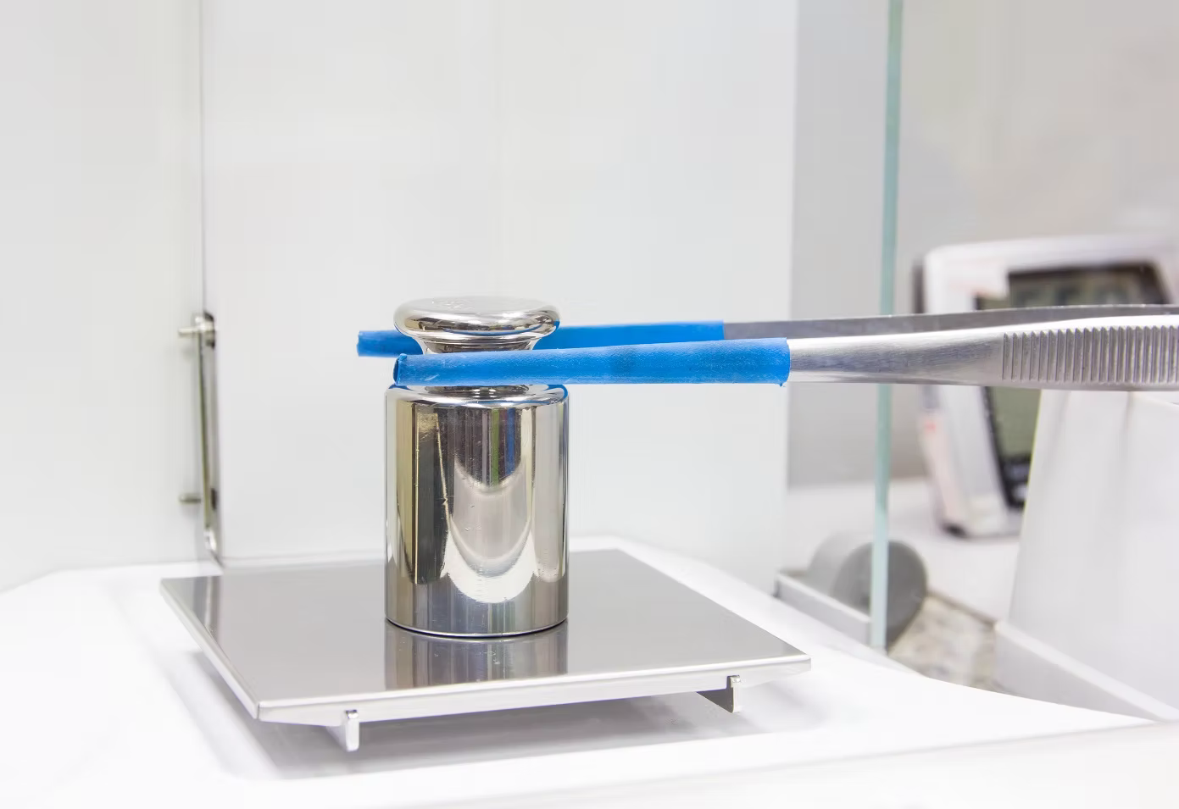
Calibration of Analytical Balance
CHAPTER 1 : SOP For Analytical Balance : Operation and Calibration
- PURPOSE: To lay down the procedure for operation and calibration of Analytical Balance for better and error free use.
- SCOPE: This procedure is applicable for Analytical Balances installed in QC Department, IPQC Department & Dispensing Department.
- RESPONSIBILITY:
  - QC Analyst shall be responsible for:
a) The operation, calibration, and maintenance of the instrument as per the SOP.
b) Maintaining the history card, Instrument usage logbook, and weight prints as per the SOP.
- QC HEAD: Has to ensure that the instrument is operated, calibrated and maintained and the related documentation is done as per the SOP.
- QA shall be responsible to ensure the implementation of the system as per the SOP.
- Plant Head and Quality Head shall be responsible for the approval of the SOP.

CHAPTER 2 : PROCEDURE FOR OPERATION AND BALANCE CALIBRATION

OPERATION PROCEDURE
- Make sure that the Balance is kept clean and placed on flat platform free from vibrations.
- Ensure that the calibration status is valid.
- Ensure that the spirit level is in the centre of the circle.
- Connect the power cable to the mains and switch "ON".
- Automatically self checking starts and ends with OFF.
- Press ON/OFF key, all the display with glow.
- Press "TARE KEY", 0.0000 marks appears on the display.
- The stability of the reading is obtained and is indicated by an arrow mark on the left side of the display.
- Once the stability is attained, the balance is ready for weighing.
- Place the material to be weighed on the pan and note down the reading after the arrow mark appears on the left side of the display.
- Clean the Balance immediately after weighing.

PRELIMINARY CHECKS FOR BALANCE CALIBRATION:

- SPIRIT LEVEL CHECK (BALANCE LEVELLING):
  - Adjust the air bubble to the centre of the inner circle of the indicator by rotating the two levelling screws at the rear base of the balance.
  - Acceptance Criteria: Air Bubble must be in the centre of the inner circle.
    - PAN CLEANING AND ADJUSTMENT:
      - Before Placing the standard weight/butter paper/glassware, clean the pan properly. Also ensure that the pan is adjusted properly (if not adjusted before).
      - Acceptance Criteria: Pan must be cleaned and centrally placed.
        - ZERO ERROR CHECK:
          - Close the sliding doors of the balance and press the Tare key and wait till LCD shows zero.
          - Acceptance Criteria: LCD Should display zero on the LCD Screen.
            - HANDLING OF WEIGHT BOX:
              - Ensure that the weights used are calibrated and certified on regular basis.
              - Always use forceps/tweezers to place the weights on the balance pan.
              - Do not drop the weights with force on the pan of the balance, to avoid any variation in the results.
              - Weights used for calibration should always be cleaned with tissue paper before and after each use.
              - Acceptance Criteria: Weights should not have any denting or damage sign and should be cleaned before and after each use.
V CARE IMPEX manufactures Standard Weights of all classes viz, E1 Class, E2 Class, F1 Class, F2 Class and M1 Class. All Weights are calibrated from ISO 17025 accredited NABL Lab and makes calibration easy and accurate for all our clients.

CALIBRATION PROCEDURE:
- FREQUENCY:
  - Each Working Day: Spirit Level Check, Pan Cleaning and Adjustment, Zero Error Check, Accuracy.
  - Weekly & After Maintenance: Spirit Level Check, Pan Cleaning and Adjustment, Zero Error Check, Accuracy, Precision/Measurement Uncertainty and corner accuracy/eccentricity test.
  - After preliminary checks are completed operate the instrument as per operation procedure described above and proceed for external calibration.
    - ACCURACY:
      - For daily calibration use 50 mg & 100 mg. Place each weight on the weighing pan. Note down the observed weight.
      - For Weekly calibration use 50 mg, 100 mg, 200 mg, 500 mg, 1g, 5g, 10g, 50g and 100g weights.
      - Record the readings as per Attachment - I for daily calibration and as per Attachment - II for Weekly calibration.
      - Acceptance Criteria: Each weighing should not differ by more than 0.1% of the actual weight.
        - PRECISION/ MEASUREMENT UNCERTAINTY:
          - Place the 50 mg weight on the weighing pan and note down the observed weight.
          - Repeat the above steps 9 times.
          - Record the results as per Attachment II
          - Calculate the Standard Deviation (SD).
          - Calculate the measurement uncertainty using the following equation:
Measurement Uncertainty = 3 x SD/ Certified value of the weight

6. Repeat above steps for 100 g weight, and record the results as per Attachment - II
7. Acceptance Criteria: Each weighing shall not differ more than 0.1% of the actual weight. Measurement Uncertainty should not be more than 0.001.

- CORNER ACCURACY/ ECCENTRICITY TEST:
Place 50g weight on the centre, front left, front right, back right back left side of the weighing pan (As Shown below) and note down the weight for each position.

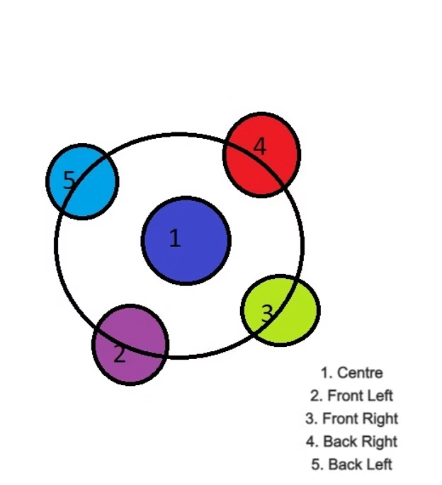
- Calculate the Difference between the observed weight and the certified weight.
- Record the results as per the Attachment - II for Weekly Calibration.
- Acceptance Criteria: Each Weighing shall not differ more than 0.1% of the actual weight.
Please Note, you can use your own format or standard format for Attachment I and Attachment II, that is, Daily calibration record of Analytical Balance and Weekly Calibration record.

